<https://youtu.be/iJ_sl6J8PRg?si=vfQ7MFlNKlMF-Zaa>

1. Agile project management is a flexible approach to building a project
2. In agile project management, project is broken down into several stages and sprints
3. Agile does not work on the principles of delivering project at the end, It works on delivering the sections of project or mini project

**Scrum is type of agile methodology**

* Agile methodology consist of several cycle or sprint at the end of each stage we get a mini project
* Product backlog: It consists of prioritize list of features. It contains all the feature from beginning to end

It takes a new feature, changes in existing feature and several other improvement in the project then we have (Product owner create prioritize list of features know as user story (requirement) they could go in the product.

* Scrum team works in sprint. Sprint is duration of 1 or 2 week
* Sprint planning meeting is conducted before every sprint which is attended by the scrum master, development team and product owner. All of them select the high priority item from the product backlog in such way that development team can deliver them in a single sprint.
* Sprint backlog: is a list of selected task that are to be completed during each sprint

Sprint- sprint consisting of planning, designing , execution, testing and deployment stages and at the end each sprint a mini project is delivered, with every sprint new features is added to product which place a significant role in the overall project growth.

After all sprint and early validation in the development final deliverable has few changes of failure.

During the sprint, every day a daily scrum meeting is held, in this meeting each participant answer the 3 questions

1-what will you do today?

2- what did you do yesterday?

3- what are impediments in your way?

Outcome of the sprint is mini project or release is delivered, it depend on product owner whether he wants some more features to be added to the product or he wants to ship the product.

* After every sprint , sprint review and print retrospective meeting are attended
* Sprint Review: In sprint review the scrum team showcases what it accomplished during the sprint. It is kind of demo of the new features added in the product
* Sprint Retrospective: the team contemplate on what went well, what went bad and what will be improved.

The objective of sprint retrospective is to improve the sprints which will be held in future.

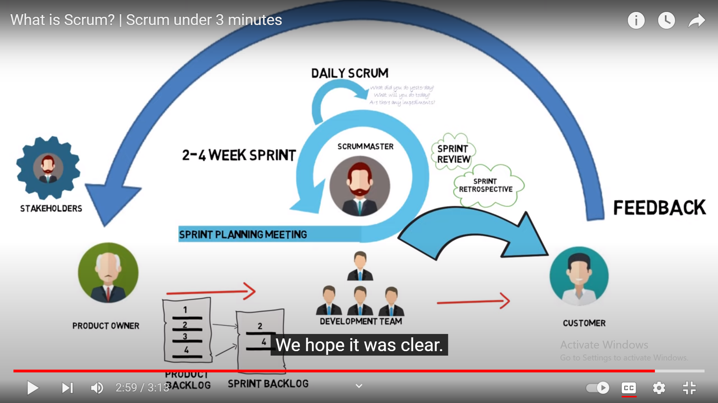

Advantage of Agile:

1. High product quality
2. High customer satisfaction
3. Reduced risk
4. Better and faster Return on investment

**Steps in Agile project Management :**

1. Project Planning: Project planning is a step that ensures everyone understands the end goal and value of that project. Here the scope is developed and the work is estimated by

Breaking it into sprints or iterations

1. Roadmap: is list of all the features that the final product should have. It acts as a plan of

Action on how a project will evolve. Hence the roadmap is an integral part of the plan as these features are built during each sprint.

1. Release planning: plan is made for all the features releases and this plan is revisited at the beginning of each sprint. Agile project methodology uses shorter development cycles or sprints, with features released at the end of each cycle.